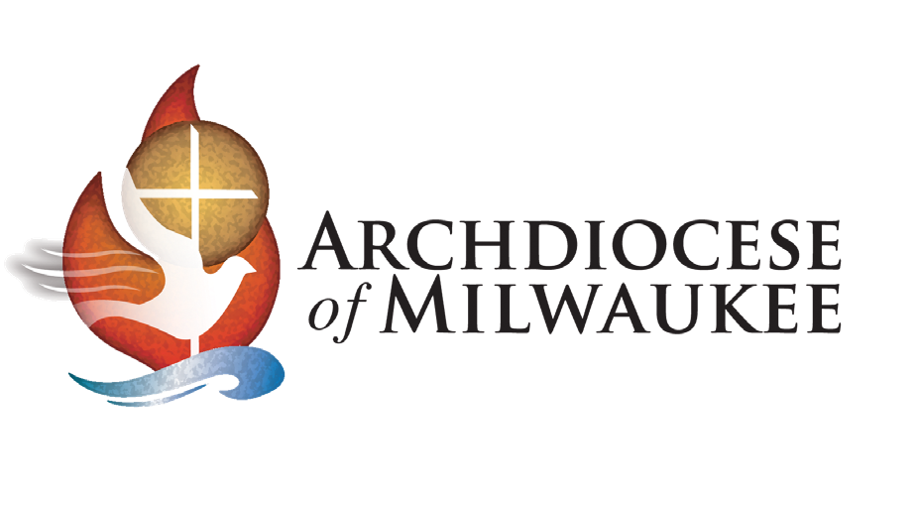

October 13, 2025

Media Advisory

For Immediate Release
Contact: Sandra Peterson, 262-271-1416

Food Program Serves Chicago-Style Pizza Today
Archdiocese of Milwaukee Winnings from Friendly Baseball Wager

Milwaukee — With the Brewers’ division win Saturday night, a Catholic food program in Milwaukee will receive the proceeds from a friendly baseball wager — Chicago-style pizza to serve to those in need for today’s lunch.

At the beginning of the National League Division series, The Most Reverend Jeffrey S. Grob, Archbishop of Milwaukee and Cardinal Blase Cupich, Archbishop of Chicago, entered into a friendly wager: Chicago-style pizza if the Brewers win and Milwaukee brats if the Cubs win. Either way, a food program in the winning city would be the beneficiary helping feed those in need.

When
10:15 am Monday, October 13

Where
Open Door Café at the Cathedral of Saint John The Evangelist
831 N. Van Buren, Milwaukee

Details
- Lou Malnati’s Pizza, which is donating the pizzas, will deliver them at 10:30 am. Media should be at the café by 10:15 am for video of the pizzas being delivered.
- Interviews with the café manager and Fr. Tim Kitzke, the Cathedral Rector, will be available before the café starts serving lunch at 11:15 am.
- Volunteers and certain guests will be available for photos/video of people being served the pizza.

Archbishop Grob Interview
1 pm at Archdiocese of Milwaukee Pastoral Center
3501 South Lake Drive, Milwaukee
###

The Open Door Café is the only hot lunch program for homeless and hungry people in Milwaukee and serves 100 to 130 meals each weekday.

The Archdiocese of Milwaukee encompasses 10 counties in southeast Wisconsin. It includes 184 parishes that provide spiritual care to more than 500,000 Catholics, 103 schools serving 27,000 students, and six cemeteries. Its Mission is to proclaim the Gospel of Jesus Christ by calling, forming and sending disciples to go and make new disciples.
The Mary Mother of the Church Pastoral Center, located in St. Francis, is the main office for the Archdiocese of Milwaukee and the Cathedral of St. John the Evangelist in Milwaukee is its mother church. The archdiocese also provides pastoral support for its sister parish, La Sagrada Familia, in the Dominican Republic.

3501 South Lake Drive, St. Francis, WI 53235
Phone: 414-769-3461 – Fax: 414-769-3388 – communication@archmil.org – archmil.org

