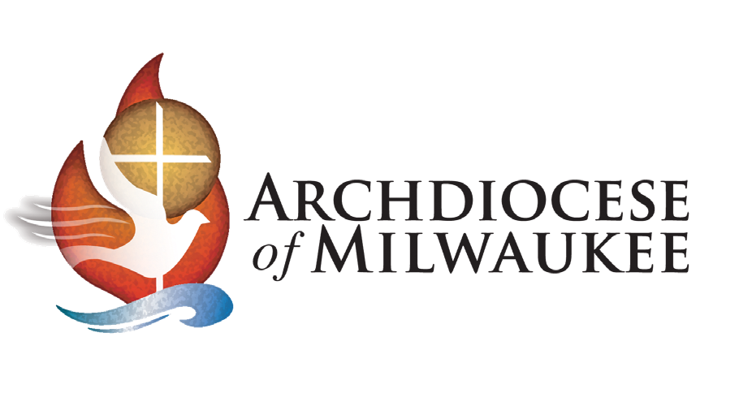

January 16, 2025

Media Release

For Immediate Release
Contact: John Bruns, 414-769-3452

Masses of Welcome with Archbishop Grob
Newly Installed Archbishop of Milwaukee

Milwaukee — As Most Rev. Jeffrey S. Grob is welcomed as the 12th Archbishop of Milwaukee, he will celebrate eight Masses of Welcome from Jan. 21 through March 3, 2025, at parishes across the Archdiocese of Milwaukee. These Masses commemorate the recently established bond between Archbishop Grob and the more than 500,000 Catholics now under his guidance in the 10-county archdiocese. All are invited to attend any of these Masses and a simple reception will follow each one.

Tuesday, January 21, 2025, 6 p.m. | Holy Family Catholic Community
271 Fourth St. Way, Fond du Lac, WI 54937

Thursday, January 30, 2025, 6 p.m. | St. Charles Parish
313 Circle Drive, Hartland, WI 53029

Thursday, February 6, 2025, 6 p.m. | St. Dominic Parish
2133 N. 22nd St., Sheboygan, WI 53081

Monday, February 10, 2025, 6 p.m. | St. Elizabeth Parish
714 49th St., Kenosha, WI 53140

Tuesday, February 11, 2025, 6 p.m. | St. Lucy Catholic Church
3101 Drexel Ave., Racine, WI 53403

Monday, February 17, 2025, 6 p.m. | Christ King Catholic Parish
2604 N. Swan Blvd., Wauwatosa, WI 53226

Monday, February 24, 2025, 6 p.m. | St. Matthias Parish
9306 W. Beloit Road, Milwaukee, WI 53227

Monday, March 3, 2025, 6 p.m. | St. Frances Cabrini Parish
1025 S. 7th Ave., West Bend, WI 53095

Archbishop Grob was recently installed as the 12th Archbishop of Milwaukee on Jan. 14, 2025, serving as the new chief shepherd of the archdiocese.

###
Media outlets are invited to cover the Masses of Welcome. Archbishop Grob will also be available for interviews directly afterward. If you plan to send a reporter/photographer to any of these Masses, please contact John Bruns, Associate Communication Director, at 414-769-3452 or brunsj@archmil.org.

The Archdiocese of Milwaukee encompasses 10 counties in southeast Wisconsin. It includes 184 parishes that provide spiritual care to more than 500,000 Catholics, 103 schools serving 27,000 students, and six cemeteries. Its Mission is to proclaim the Gospel of Jesus Christ by calling, forming and sending disciples to go and make new disciples.

The Mary Mother of the Church Pastoral Center, located in St. Francis, is the main office for the Archdiocese of Milwaukee, and the Cathedral of St. John the Evangelist in Milwaukee is its mother church. The archdiocese also provides pastoral support for its sister parish, La Sagrada Familia, in the Dominican Republic.

3501 South Lake Drive, St. Francis, WI 53235
Phone: (414) 769-3461 – Fax: (414) 769-3388 – communication@archmil.org – archmil.org

